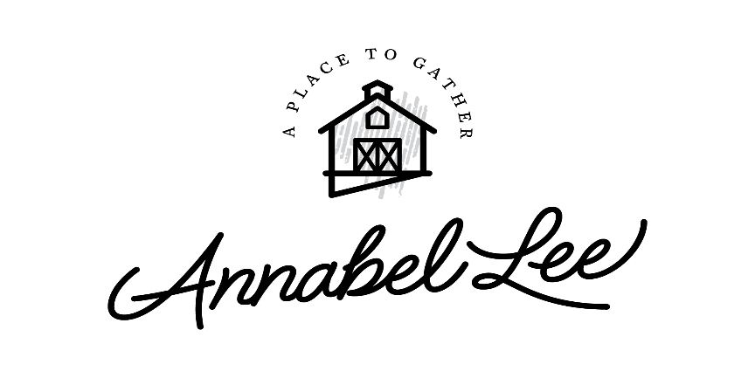

Welcome Annabel Lee Barn Guests!

Country charm awaits you at the rustic Annabel Lee Barn. My husband, Steve, and I look forward to sharing our historic 1907 barn, which we restored and rebuilt in 2019. It offers the warmth, elegance, and relaxation for your stay with all the modern amenities. This welcome letter provides all the information you will need to know from turning on the lights to fun adventures, and delicious places to eat in historic downtown Dubuque, IA. So, let us get started!

Location and Contact Information
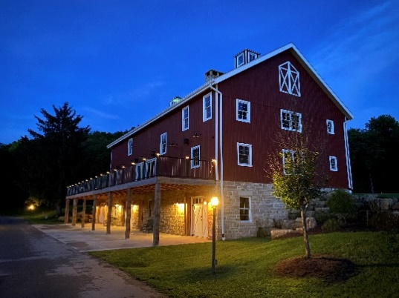
Annabel Lee Barn
2319 Manson Road
Dubuque, IA 52003

Questions: Call or text Kristin – 563-543-7200
*FYI…this Welcome Letter, as well, all the APPS
explained below are located on the TABLET in
kitchen of the barn.
When you arrive, you will enter a white gate. The gate will be open for you. When you reach the “Y” in the road, stay to your left and park at the top of the barn. The big barn door will be unlocked for your arrival. Your KEY to RELAXATION is located by your Welcome Goodie Basket on the kitchen counter. Please lock up when you are out and about on other adventures! Use gate opener for the white gate, as it will be closed during your stay. It will automatically open on your way out. Use the opener on the way back in.
Lights
There are two main wall switches that can turn ALL the barn lights on and off. When you enter, the wall to your right has the main floor switch and is marked BARN ON (green sticker) and BARN OFF (red sticker). The other main switch is in the basement by the garage door. There are more switches throughout the barn, like in the kitchen and bathrooms, however, you may also run the lights through an app called LUTRON. This app is already set up on the tablet in the kitchen. If you would like to download the app onto our phone, you will need to connect to The Barn Wi-fi.


WiFi
To connect to the barn internet, use the The Barn Wi-Fi connection.
- PASSWORD - audioexperts1
Now you may download the Light App – LUTRON

Music
If you would like to play music throughout the barn, you may find the SONOS App on the tablet in the kitchen, and you may also download this app to your phone. Just remember to be connected to The Barn Wi-Fi. Once you are connected and have SONOS downloaded, you may connect to Pandora or music of your choice. Music may be piped through different areas of the barn, too!

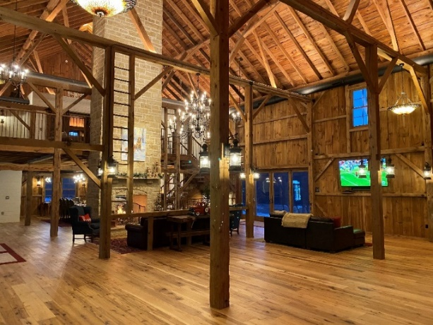


TV’s
Every TV has its own main remote, which is labeled on the back. Use the Main Remote to control the TV.
- TV by couch on Main Floor:
- Power On
- Press Input to watch cable or play a DVD.
- Use HDMI I for Cable
- Use HDMI 4 to play DVD (use small Pioneer Remote to control DVD Player-remote may be in master suite.)
ALL TVs are Smart TVs, so other Apps may be accessed to watch movies, etc. Please use your personal logins to access these specialty apps. However, make sure you logout when you leave, so other guests do not accidentally use your account. YIKES!
- TV in Loft Master Suite:
- Power On
- Press Input to watch cable or play a DVD.
- Use HDMI 2 for Cable
- Use HDMI 3/ARC to play DVD (use small Pioneer Remote to control DVD Player)
Other TVs work in a similar way.
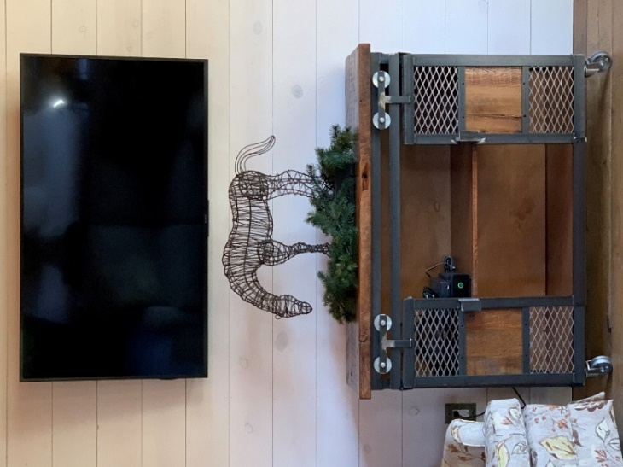

Fireplaces
There are two wood burning fireplaces that have quick gas lighting starts!
Fireplace Instructions:
- Load wood in fireplace.
- Crack some windows/and or door for ventilation purposes – or it will get smoky inside!
- Locate Gas Key:
- Mail Level (2-sided) Fireplace – Left side of top mantle (side with dog painting)
- Upstairs Loft – Right side of top mantle
- Put key in gas on/off valve – located to the left (main floor) or right (loft) of fireplace.
- Turn the key counterclockwise to turn gas on.
- Use a match to light the fireplace.
- When logs are burning (about 5 minutes), turn gas OFF– turn clockwise.
- Return key on top of the mantle to make sure gas is off and for safety purposes.
- ENJOY!
*If you need extra wood, there is some in the wood box and down in the basement.
*Steve is happy to start your fire for you! Just give us a call! 563-543-7200

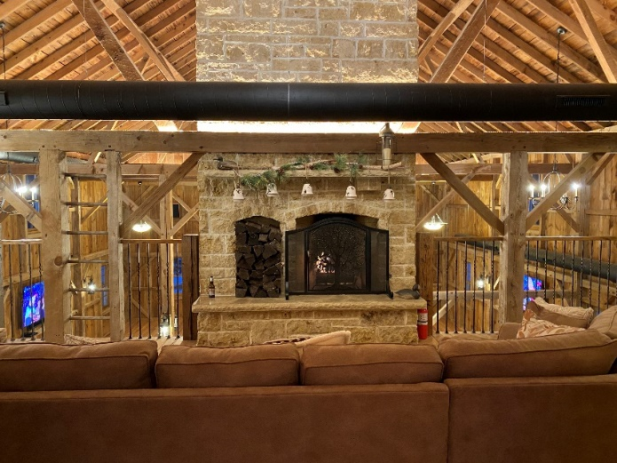
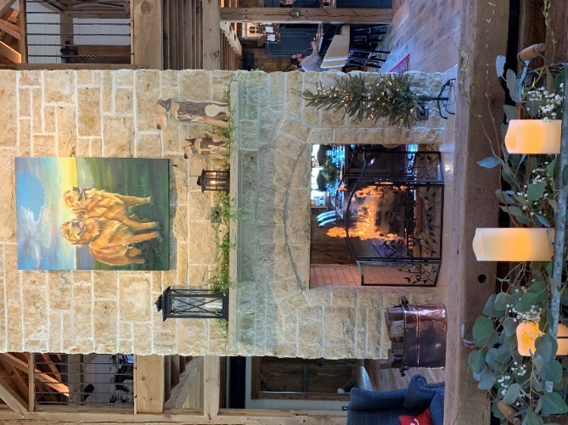

Heating and Cooling
The thermostat is located on the left side of the bar. Please feel free to adjust to your needs.
Murphy Bed
The queen size Murphy Bed is a hidden treasure! It is in the grey cabinet in the loft. Below are directions on how to pull-out the Murphy Bed:

Food and Entertainment
There are brochures in the kitchen for places to eat and entertainment to enjoy. Below are links to websites as well:

Dining – Go to Dubuque365
https://dubuque365.com/dining/
Events – Go to Dubuque365
https://dubuque365.com/events/#more-16500
Music – Go to Dubuque365
https://dubuque365.com/music/

Adventures
You are welcome to enjoy a morning walk along Catfish Creek, which is located in the valley below the barn. For more adventures, see links below for area hiking trails and historic sites to see in Dubuque:
- 25 Best Things to Do in Dubuque, Iowa
https://vacationidea.com/destinations/dubuque-iowa.html
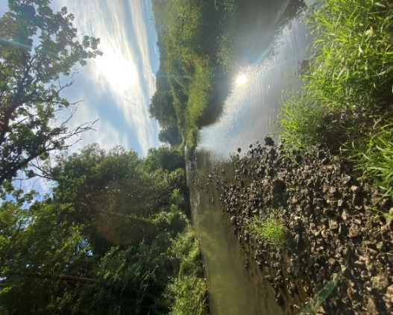
(The Fenelon Place Elevator is a must see! Stonecliff Winery is along the Mississippi River Walk and next to the historic Shot Tower. If you enjoy museums, the National Mississippi River Museum & Aquarium is a great way to spend a morning or afternoon. Lots of great things on this list…. just enjoy!)

- Mines of Spain
8991 Bellevue Heights Road
Dubuque, IA 52003
563-556-0620
https://www.minesofspain.org/

- Swiss Valley Park
13069 Swiss Valley road
Peosta, Iowa 52068 Catfish Creek

https://www.mycountyparks.com/County/Dubuque/Park/Swiss-Valley-Park.aspx

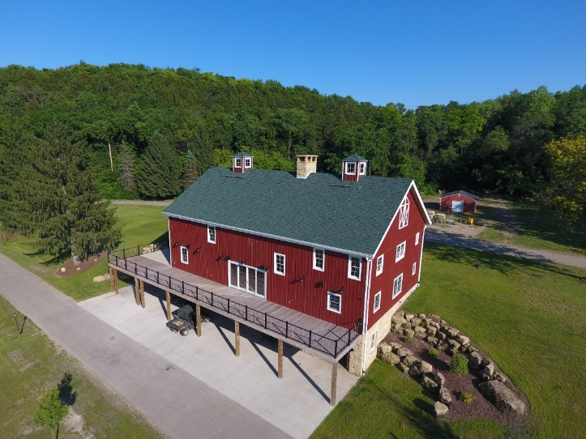


CHECK-OUT: Please look for a check-out form on the kitchen counter when you leave the …

“Don’t cry because it’s over, smile because it happened.”
~ Dr. Seuss
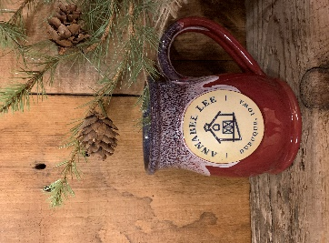
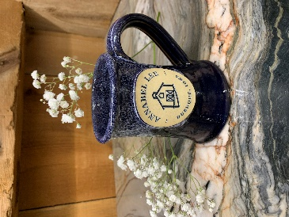
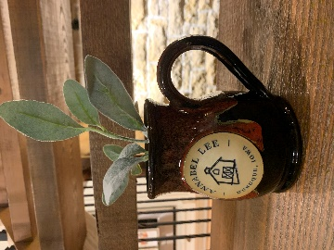
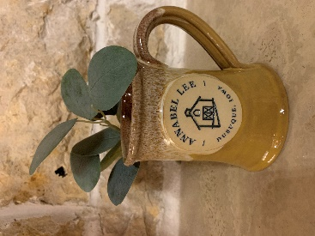

Creekside Sunset Midnight Moon Barnyard Days Flaming Ambience

LOVE our Annabel Lee Mugs?
Take one home as an Iowa Barn Getaway keepsake!
Only $24.99 – Purchase at www.annabelleebarn.com or let Kristin know!

